**Multiple choice answers**

***Multiple choice answer sheet. Shade in the one answer you think to be best.***

|  |  |  |
| --- | --- | --- |
| ⒈ **Ⓐ** Ⓑ Ⓒ Ⓓ  ⒉ Ⓐ **Ⓑ** Ⓒ Ⓓ  ⒊ Ⓐ Ⓑ **Ⓒ** Ⓓ  ⒋ Ⓐ Ⓑ Ⓒ Ⓓ  ⒌ Ⓐ Ⓑ Ⓒ **Ⓓ**  ⒍ Ⓐ Ⓑ Ⓒ Ⓓ  ⒎ Ⓐ Ⓑ Ⓒ  ⒏ Ⓐ Ⓑ Ⓒ Ⓓ  ⒐ Ⓐ Ⓑ Ⓒ Ⓓ  ⒑ Ⓐ Ⓑ Ⓒ Ⓓ | 11 Ⓐ Ⓑ Ⓒ Ⓓ  12 Ⓐ Ⓑ Ⓒ Ⓓ  13 Ⓐ Ⓑ Ⓒ Ⓓ  14 Ⓐ Ⓑ Ⓒ Ⓓ  15 Ⓐ Ⓑ Ⓒ Ⓓ  16 Ⓐ Ⓑ Ⓒ Ⓓ  17 Ⓐ Ⓑ Ⓒ Ⓓ  18 Ⓐ Ⓑ Ⓒ Ⓓ  19 Ⓐ Ⓑ Ⓒ Ⓓ  20 Ⓐ Ⓑ Ⓒ Ⓓ | 21 Ⓐ Ⓑ Ⓒ Ⓓ  22 Ⓐ Ⓑ Ⓒ Ⓓ  23 Ⓐ Ⓑ Ⓒ Ⓓ  24 Ⓐ Ⓑ Ⓒ Ⓓ  25 Ⓐ Ⓑ Ⓒ Ⓓ  26 Ⓐ Ⓑ Ⓒ Ⓓ  27 Ⓐ Ⓑ Ⓒ Ⓓ  28 Ⓐ Ⓑ Ⓒ Ⓓ  29 Ⓐ Ⓑ Ⓒ Ⓓ  30 Ⓐ Ⓑ Ⓒ Ⓓ |

**Question 31. (18 marks)**

Use the graphs below to answer question 31. Body mass index is ratio of someone’s body mass to height.

(a) With regard to type 2 diabetes state one trend shown in the two graphs above?

(1 mark)

**As BMI increases so to the relative risk of Type 2 diabetes increases.**

(b) What is the independent variable in the graph above? Give a reason for your answer.

(2 marks)

**BMI(1 mark)**

**It is The variable that will cause a change.(1 mark)**

(c) What is the relative risk of Hypertension for a man of Body-Mass Index 25?

_________________________________________________________________________(1 mark)

(d) Explain the effect of Type 2 diabetes on the regulation of blood glucose

(2 marks)

________________________________________________________________________________

________________________________________________________________________________

________________________________________________________________________________________________________________________________________________________________

(e) Type 2 diabetes may increase the risk of Alzheimer's disease. The poorer your blood sugar control, the greater the risk appears to be. The exact connection between these two conditions still remains unclear. What are the symptoms of Alzheimer’s disease and what changes occur in the brain that bring about the symptoms?

(6 marks)

________________________________________________________________________________

_______________________________________________________________________________________________________________________________________________________________________________________________________________________________________________________________________________________________________________________________________________________________________________________________________________________________________________________________________________________________________________________________________________________________________________________________________________________________________________________________________________________________________________________________________________________________________________________________________________________________________________________________________________________________________________

(f) A worldwide study starting next year in Perth and other cities around the world will test the effect of insulin sensitising drugs on the incidence of Alzheimer’s.

(i) What hypothesis would they be testing? (1 mark)

________________________________________________________________________________

________________________________________________________________________________

(ii) The scientists have decided to use a placebo in this study. What is a placebo and what is the advantage of using a placebo in a scientific trial? (2 marks)

________________________________________________________________________________

________________________________________________________________________________

(iii) The scientists have also decided to use a double blind trial. What is the main advantage of such a trial? (1 mark)

________________________________________________________________________________

________________________________________________________________________________

______________________________________________________________________________________________________________________________________________________________________________________________________________________________________________________________________________________________________________________________

(g) Fifty years ago, a drug called thalidomide was given to pregnant women to cure their morning sickness. Soon a causal link between the drug and the number of babies being born without arms and/or legs was identified. In 1998, the United States Food and Drug Administration approved the use of thalidomide to treat leprosy and now scientists are looking to trial it in the treatment of AIDS, tuberculosis and some types of cancer. What ethical criteria must be considered prior to permitting the use of thalidomide for these diseases? (2 marks)

________________________________________________________________________________

________________________________________________________________________________

________________________________________________________________________________

________________________________________________________________________________

**Question 32. (6 marks)**

(a) What is an antibiotic? (1 mark)

___**Chemical that kills bacteria**(1 mark)_______________

(b) Which of the two bacteria grown is most resistant to the Penicillium notatum? Give a reason for your choice. (2 mark)

E.coli and H. influeinzae(1 mark).

Their growth has not been inhibited by the antibiotic. __________________________________

(c) Viral particles for the virus causing the common cold were spread on the petri dish above. Would it have been able to grow (give a reason for your answer)?

(2 mark)

**NO(1 mark)**

**Virus need to replicate in a living cell(1mark)**

_______________________________________________________________________________

(d) What natural process could have led to the bacteria becoming resistant to this antibiotic? (1 mark)

**Natural selection** ________________________________________________________________________________

**Question 33. (11 marks)**

Glucose tolerance test. To confirm diabetes, a person will normally take a glucose tolerance test in a hospital. Patients do not eat for 12 hours before the test. This gets their blood glucose to its lowest level. They are then given a drink containing 75g of glucose and their blood glucose level is monitored over the next two hours**.** Use this data to answer question on the next page.

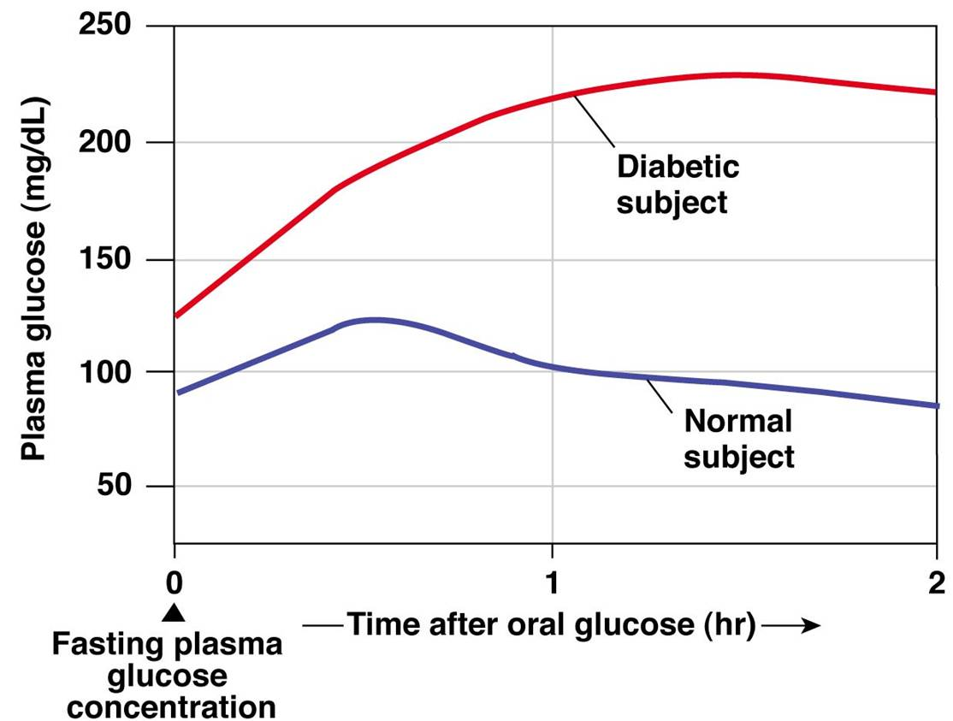

1. Describe what has happened in the body of the normal subject in the two hours after the consumption of the glucose drink.

(5 marks)

________________________________________________________________________________

________________________________________________________________________________________________________________________________________________________________

________________________________________________________________________________

________________________________________________________________________________________________________________________________________________________________

________________________________________________________________________________

________________________________________________________________________________________________________________________________________________________________

________________________________________________________________________________

________________________________________________________________________________________________________________________________________________________________

________________________________________________________________________________

________________________________________________________________________________________________________________________________________________________________

________________________________________________________________________________

________________________________________________________________________________________________________________________________________________________________

________________________________________________________________________________

________________________________________________________________________________________________________________________________________________________________

(b). below is the insulin levels in an individual recorded over one day. Use to answer the questions that follow.

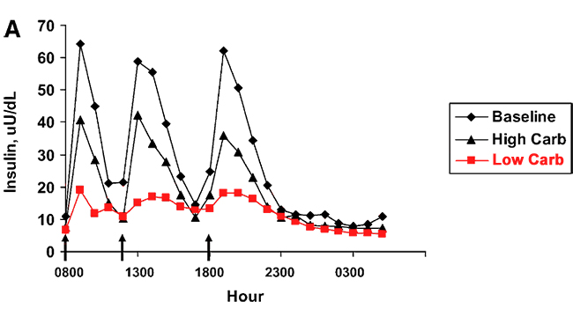

**The time is given in 24 hour Clock**

1. Is the individual normal or diabetic? Give a reason for your answer.

(2 marks)

_________________________________________________________________________________________________________________________________________________________________________________________________________________________________________________________________________________________________________________________________________________________________________________________________________________________________________________________________________________________________________________

1. From this graph state how often the person ate, the times that they ate at and the reason for your choice of times.

(4 marks)

_________________________________________________________________________________________________________________________________________________________________________________________________________________________________________________________________________________________________________________________________________________________________________________________________________________________________________________________________________________________________________________

**Question 34. (5 marks)**

In humans, it has been observed that the heartbeat originates in the heart itself.

(a) Name the structure in the heart that is responsible for the origin of the heartbeat.

(1 mark)

________________________________________________________________________________

(b) There are two sets of nerves that are sent to the heart. Which nerve pathway would cause the heart rate to slow? (1 mark)

________________________________________________________________________________

(c) If you are seated and then stand up and start walking, your heart rate increases. What structure in the brain is responsible for this increase in heart rate? (1 mark)

________________________________________________________________________________

(d) Heart rate increases during exercise. State two stimuli that occur as a result of exercise that will cause this reaction. (2 marks)

________________________________________________________________________________

________________________________________________________________________________

________________________________________________________________________________

________________________________________________________________________________________________________________________________________________________________________________________________________________________________________________

**Question 35. (8 marks)**

The diagram below shows part of the process of protein synthesis.

[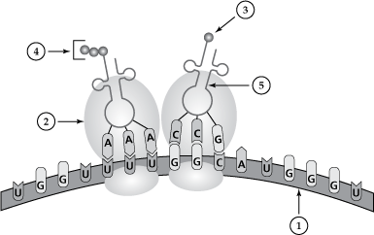](http://www.google.com.au/url?sa=i&rct=j&q=protein+translation+diagram&source=images&cd=&cad=rja&docid=sVh3265btovfUM&tbnid=6wwYFcFV1wfkSM:&ved=0CAUQjRw&url=http://mdk12.org/instruction/clg/public_release/biology/G3_E2_I1.html&ei=oM4WUrK4F47MkQXu9IBI&psig=AFQjCNEYBxjdH-S5biysDZEeFDJQK1_S9Q&ust=1377312788122406)

(a) What is this part of the process called? (1 mark)

________________________________________________________________________________

(b) Name the following structures: (4 marks)

1. _________________________ 4. _________________________

2. _________________________ 5. _________________________

(c) (i) How is structure 1 similar to DNA? (1 mark)

________________________________________________________________________________

________________________________________________________________________________

(ii) How is structure 1 different to DNA? (2 marks)

________________________________________________________________________________

________________________________________________________________________________

________________________________________________________________________________

**Question 36. (15 marks)**

The diagram below shows the relationship between the hypothalamus, pituitary and the ovary.

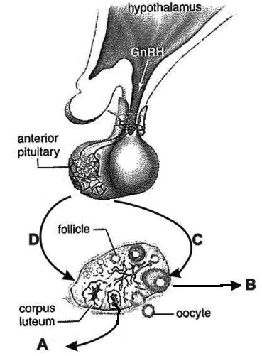

(a) Which hormones do the labels A, B, C and D represent? (4 marks)

A _____________________

B _____________________

C _____________________

D _____________________

(b) A hormone cascade pathway is one in which the secretions of one endocrine gland cause the secretion of hormones from another endocrine gland. Besides the example shown in the diagram above, state one other cascade pathway, naming the endocrine glands involved and the hormones released. (2 marks)

________________________________________________________________________________

________________________________________________________________________________

________________________________________________________________________________

________________________________________________________________________________

(c) Complete the table below comparing the different categories of hormones.

(4 marks)

|  |  |  |
| --- | --- | --- |
|  | Amine based hormone | Steroid based hormone |
| Where receptors can be located |  |  |
| Effect on cell activity |  |  |

(d) It is possible to transplant a working pancreas into a patient suffering from Type I diabetes in order to cure the disease. Explain why the use of stem cells to replace the faulty pancreas would be a better option than transplant surgery?

(2 marks)

________________________________________________________________________________

________________________________________________________________________________

________________________________________________________________________________

________________________________________________________________________________

________________________________________________________________________________

________________________________________________________________________________

(e) Give three advantages of the use of Recombinant DNA technology in the treatment of Classic haemophilia brought about by a lack of factor VIII.

(3 marks)

________________________________________________________________________________

________________________________________________________________________________

________________________________________________________________________________

________________________________________________________________________________

________________________________________________________________________________

________________________________________________________________________________

**Question 37. (8 marks)**

(a) Label the diagram below and use it to answer the question that follows.

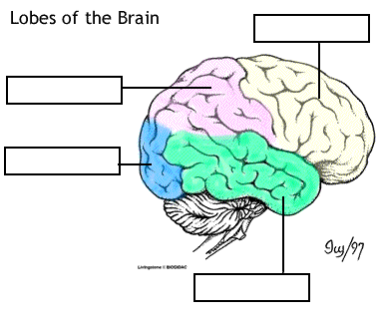

(4 marks)

(b) Based on the previous diagram complete the table below.

|  |  |
| --- | --- |
| Functional area | Lobe of brain that the area is located in |
| Sensory |  |
| Movement |  |
| Personality |  |
| Vision |  |

(4 marks)

**Question 38. (9 marks)**

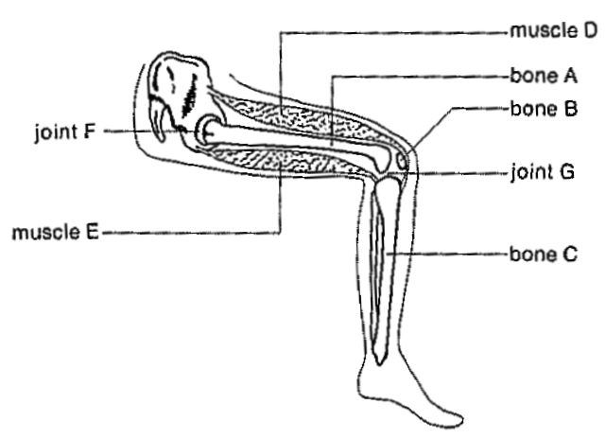

(a) State two ways in which friction is reduced in Joint G. (2 mark)

________________________________________________________________________________

________________________________________________________________________________

________________________________________________________________________________

________________________________________________________________________________________________________________________________________________________________________________________________________________________________________________

(b) (i) describe the movement of the leg, using the appropriate term, when muscle D contracts? (1 mark)

________________________________________________________________________________

(ii) Muscle E is relaxing when muscle D contracts. What is this relationship between the two muscles called? (1 mark)

________________________________________________________________________________

(c) Bone A has to withstand extremely strong forces. In fact, bone A is the strongest bone in the human body. Describe one way in which its microscopic organisation has increased its strength. (1 mark)

________________________________________________________________________________

________________________________________________________________________________

(d) Complete the table to show how joints F and G are similar, yet different. (3 marks)

|  |  |
| --- | --- |
| How Joints F and G are Similar | How Joints F and G are Different |
|  |  |

(e) Describe one characteristic that differs between the pelvis of an ape and human.

(1 mark)

________________________________________________________________________________

________________________________________________________________________________

________________________________________________________________________________

________________________________________________________________________________

**Question 39. (12 marks)**

Strontium (Sr) is a pure metal with many stable and unstable isotopes. It is abundant in nature and is found primarily in volcanic rock and soils. As soils erode and filter into water and food sources, strontium is taken into the body of living organisms where it is incorporated into bone tissues in the same way as calcium. The ratio of strontium isotopes also varies from one geographical location to another. One isotope of strontium is Sr 90 .Use this information and the table below to answer the questions that follow.

Percentage of Strontium Sr90 Isotope and Time

|  |  |  |  |  |  |  |  |  |  |  |  |  |  |  |  |  |
| --- | --- | --- | --- | --- | --- | --- | --- | --- | --- | --- | --- | --- | --- | --- | --- | --- |
| |  |  | | --- | --- | | ***Time (years)*** | ***% Strontium-90 remaining*** | | 0 | 100 | | 28 | 50 | | 56 | 25 | | 84 | 12.5 | | 112 | 6.25 | | 140 | 3.125 | | 168 | 1.5625 | |

(a) Graph this data onto the graph grid on the next page. (5 marks)

(There is a spare graph page at the end of this booklet. If you need to use it, cross this graph out completely and write, “See spare graph grid” on the grid below).



1. Can Sr90 be used for absolute dating? Give a reason for your answer.

(2 mark)

________________________________________________________________________________

________________________________________________________________________________

________________________________________________________________________________

________________________________________________________________________________

1. Other than absolute dating what are two uses that Sr90 content could have in archaeology?

(2 marks)

________________________________________________________________________________

________________________________________________________________________________________________________________________________________________________________

1. A bone tool handle was found with a Sr90 content of 75%. How long has the animal that the bone came from been dead?

(1 mark)

________________________________________________________________________________

1. Was your answer to question 39 (d) extrapolation or interpolation? Give a reason for you answer.

(2 marks)

________________________________________________________________________________

________________________________________________________________________________________________________________________________________________________________

________________________________________________________________________________

________________________________________________________________________________________________________________________________________________________________

**Question 40. (8 marks)**

You hope to study a gene that codes for a neurotransmitter in human brain cells. You know the amino acid sequence of the protein.

(a) Name the procedure you would need to undertake in order to produce: (2 marks)

(i) multiple copies of the gene to study.

________________________________________________________________________________

(ii) a quantity of the neurotransmitter for evaluation as a potential medication.

________________________________________________________________________________

(b) Describe the procedure you would use to produce multiple copies of the gene. (6 marks)

________________________________________________________________________________

________________________________________________________________________________________________________________________________________________________________

________________________________________________________________________________________________________________________________________________________________

________________________________________________________________________________________________________________________________________________________________

________________________________________________________________________________________________________________________________________________________________

________________________________________________________________________________

________________________________________________________________________________________________________________________________________________________________

________________________________________________________________________________________________________________________________________________________________________________________________________________________________________________________________________________________________________________________________

________________________________________________________________________________

________________________________________________________________________________

**End of Section Two**

**Section Three: Extended answer 20% (40 Marks)**

This section contains **three (3)** questions. You must answer **two (2)** questions. Write your answers in the space provided.

Spare pages are included at the end of this booklet. They can be used for planning your responses and/or as additional space if required to continue an answer.

* Planning: if you use the spare pages for planning, indicate this clearly at the top of the page.
* Continuing your answer: if you need to use the space to continue an answer, indicate in the original answer space where the answer is continued, i.e. give the page number. Fill in the number of the question(s) that you are continuing to answer at the top of the page.

Responses could include clearly labelled diagrams with explanatory notes; lists of points with linking sentences; labelled tables and graphs; annotated flow diagrams with introductory notes.

Suggested working time: 50 minutes.

________________________________________________________________________________

**Question 41. (20 marks)**

(a) Two skulls were found at an archeological dig site. The researchers were surprised as one skull (Skull A) showed primitive hominin skull features and the other(Skull B) showed modern Homo sapiens features. List what the differences in skull features would be between the primitive and modern hominin. It was estimated that Skull B was 10000 thousand years old.

(6 marks)

(b) What are two characteristics that the two skulls would share to aid an erect stance? State how it is they aid standing erect.

(4 marks)

(c) During the biological evolution of hominins from the earliest australopithecines to early Homo sapiens, there were also significant cultural advances, including tool cultures. Describe these advances in tool culture with reference to the particular hominin groups of australopithecines, Homo habilis, Homo erectus and early Homo sapiens. Including manufacture and uses.

(8 marks)

(d) Could DNA analysis be used to compare the relationship between the two skulls?

(2 marks)

**Question 42. (20 marks)**

(a) With the extreme cold temperatures seen in some parts of Europe recently, regulation of body temperature can become a matter of life and death, especially for the aged. Explain how human bodies typically act to maintain core body temperature under cold conditions, both physiologically and behaviourally. (12 marks)

(b) In 1775, a typhoon reduced the population of Pingelap, an island in Micronesia from 2000 to 20. Among the survivors was a person heterozygous for achromatopsia, an inherited form of total colour blindness. Describe how and why the gene pool of this population would have been affected by this event over time if this is an isolated population. (4 marks)

(c) Describe how mature osteocytes are supplied with their requirements.

(4 marks)

**Question 43. (20 marks)**

(a) Allele frequency can be changed by random genetic drift and genetic bottle necks.

(i) What is meant by allele frequency?

(1 marks)

(ii) Give a brief description of random genetic drift and state what type of populations it can have the greatest impact on?

(2 marks)

(iii) Give a brief description of genetic bottle necks and give one possible cause.

(3 marks)

(iv) Natural selection can also alter allele frequency. Briefly describe natural selection.

(4 marks)

(b) In recent years protein analysis and DNA analysis have been used to investigate evolution.

(i) Explain how both of these methods can be used.

(4 marks)

(ii). Darwin did not have these two methods of analysis available to him. State and briefly explain the two sources of evidence that were available to him.

(4 marks)

(iii). State one more source of evidence for evolution and describe it.

(2 marks)

**End of Questions**